CFLC /German 1, Assignment 2
Assignment 2 (weighting 10%):

Ich in 10 Jahren

- Imagine your life in ten years.
- Please describe your future life (150 words).
- Please describe your plans (möchte): what are you planning to do, are you planning to have a family (what is your family like?) etc.?
- The following words must be included in your assignment:
-Beruf 摄影师
-verheiratet 已婚
-Hobby(s) 踢球
-Sohn/Tochter 一个儿子和一个女儿
-Hund/Katze/Haustier 鸟儿
-Wohnort (ich wohne in…) 住在广州在福建工作
-immer 玩吉他
-nie 很晚睡
-Urlaub 去德国和日本旅游
-Sport 偶尔去运动，周六周日

- Try to express as much as you can in German. Besides grammatical consistency, it is possible to get points on creativity and the range of vocabulary used.
- Submit the written text (hard copy) to your German teacher together with the rubric below.
- The documents must include your name, Student ID, section of German class and a copy of the rubric below.
- The deadline is: December 5th

FAQs
- Can I use a (online) dictionary to look up a word I don’t know in German?
Yes, of course.

- Can I use baidu/google translate to translate my entire text from Chinese/English to German?
No. The objective of this assignment is to help you learn to use new structures/words in German, and to prepare for the writing part of the final exam. Doing this anyway will result in failing this assignment.

- Can I ask a (German) friend or a classmate to help with this assignment?
Yes, as long as it is clear that most of the assignment was written by you (in German). Using grammatical structures that are clearly way above your level will also be considered as ‘clearly not the result of the student’s own work’ and will result in you failing this assignment.

- Can I copy/paste an existing text from the internet?
Obviously not: this is called plagiarism.

Assignment 2:
1: Name: Student ID: Section:
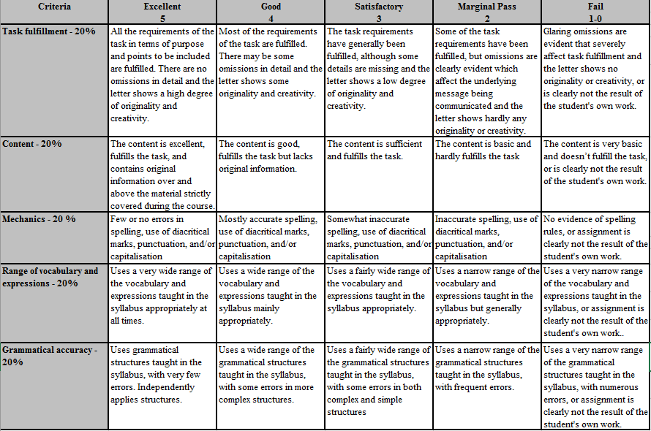

Rubric adapted with the kind permission of HKBU Foreign languages section of the Language Center

